Standard Operation Procedure - SOP

Nokia Networks

HDD Replacement EXADATA Server’s

Author: Bharat Singh Bisht

Creation Date: 08th Oct 2020

Last Updated:

# **Document Control**

## **Change Record**

3

| Date | Author | Version | Change Reference |
| --- | --- | --- | --- |
| 08-Oct-2020 | Bharat Singh bisht |  | No Previous Document |
|  |  |  |  |

## **Reviewers**

| Name | Position |
| --- | --- |
|  | Project Manager, Nokia |
|  | Network architect, Nokia |
|  | Technical Architect, HP |
|  | Service Manager, Atos |

## **Related Documents**

Follow DOC id: How to Replace a Hard Drive in an Exadata Storage Server (Predictive Failure) (Doc ID 1390836.1)

SR No: **SR 3-23764523581 : 11 disks offline shows in exadata x5**

Pre-Checks of Cell Storage Server:

Current Storage status before HDD replacement

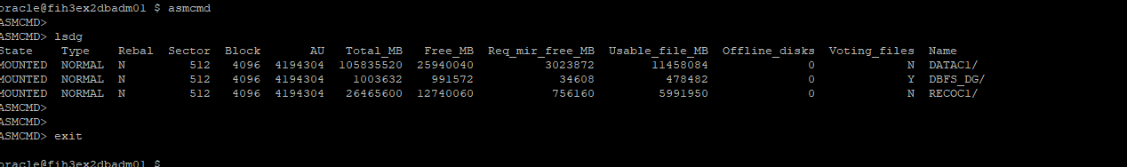

1. LUN Detail where fault Disk is identified

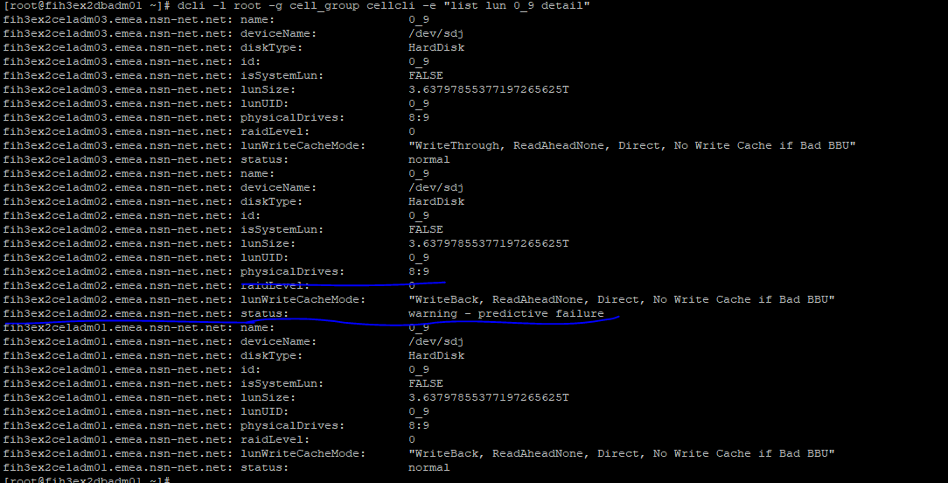

1. Cell Disk Detail

Note Creation Time after replacement

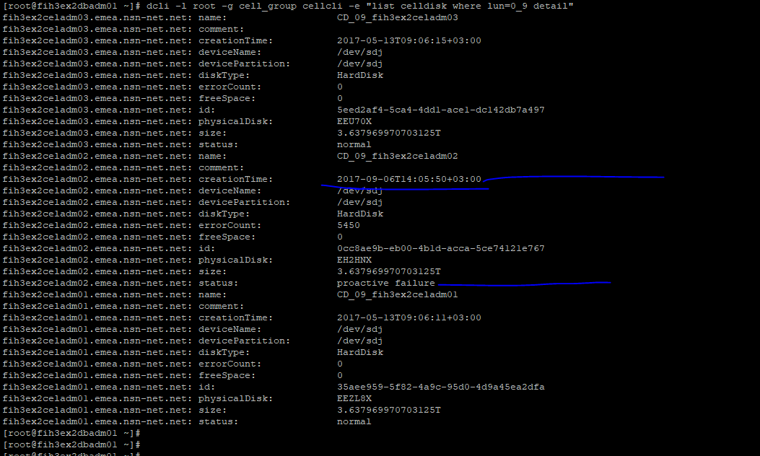

1. Grid Disk Status

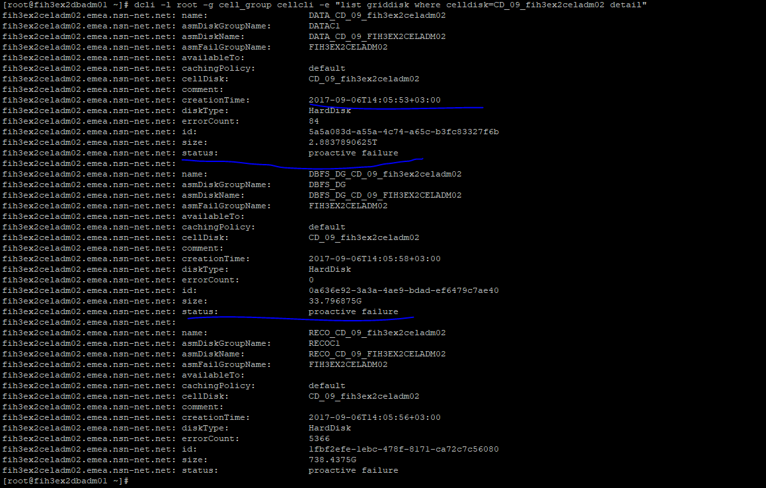

1. Check physicaldisk Status

Note: 

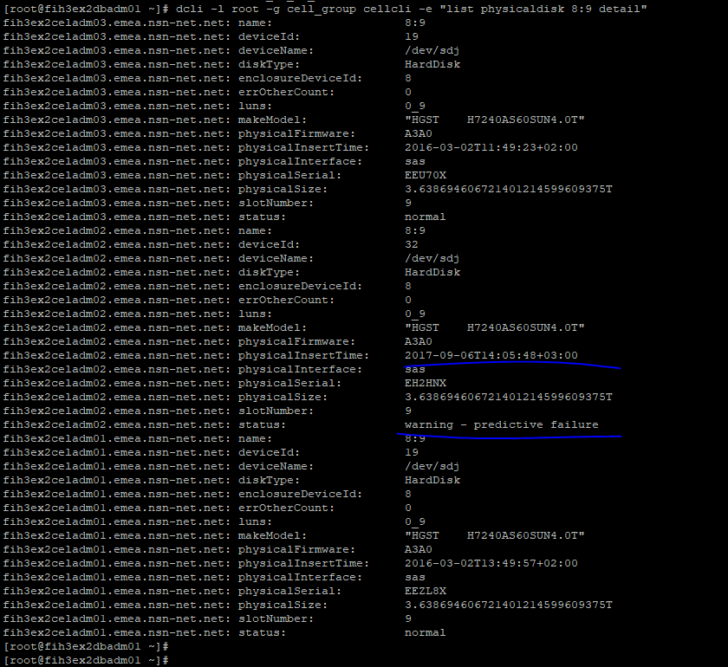

While HDD insert back to controller below status

Status: Not present

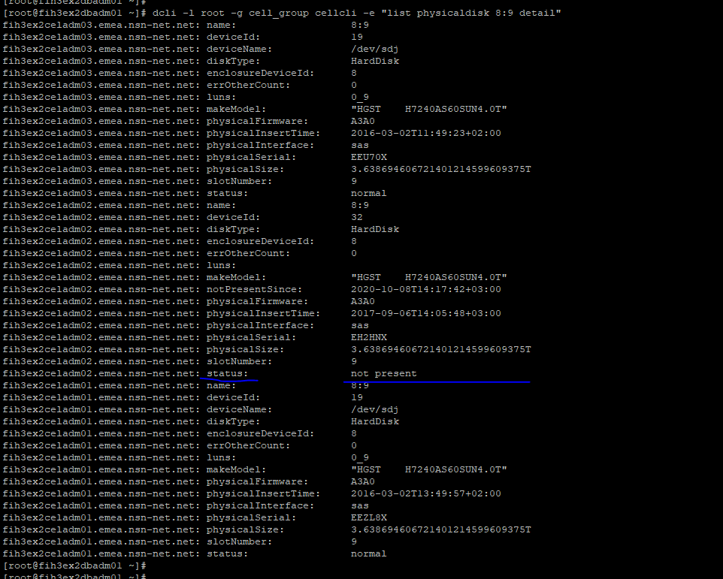

Post Checks status after HDD new inserted into drive

Wait to 3 minutes to updated Green signal on slot

1. LUN Detail

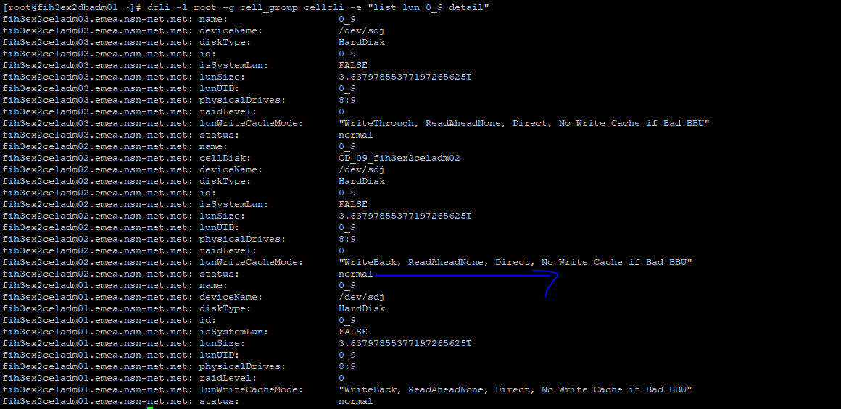

1. Cell Disk Status post HDD replacement

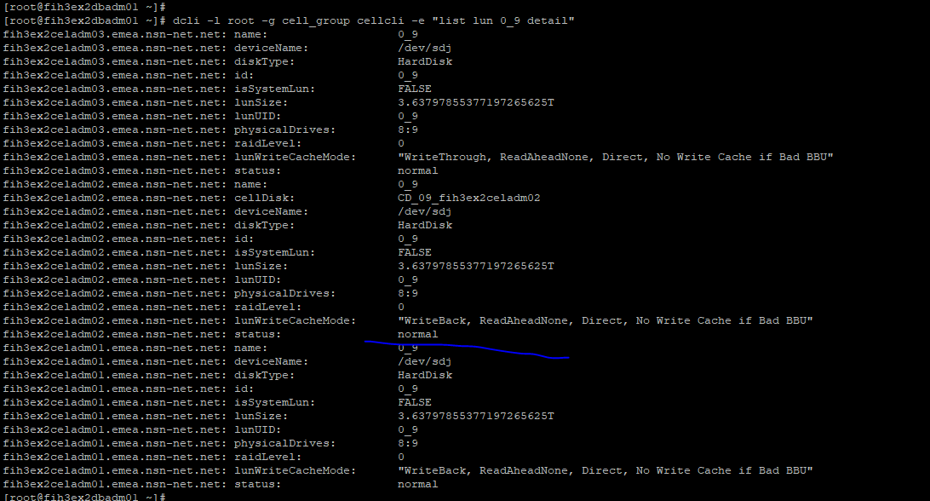

1. Grid Disk status

Note: Creation Time and status should be updated today time

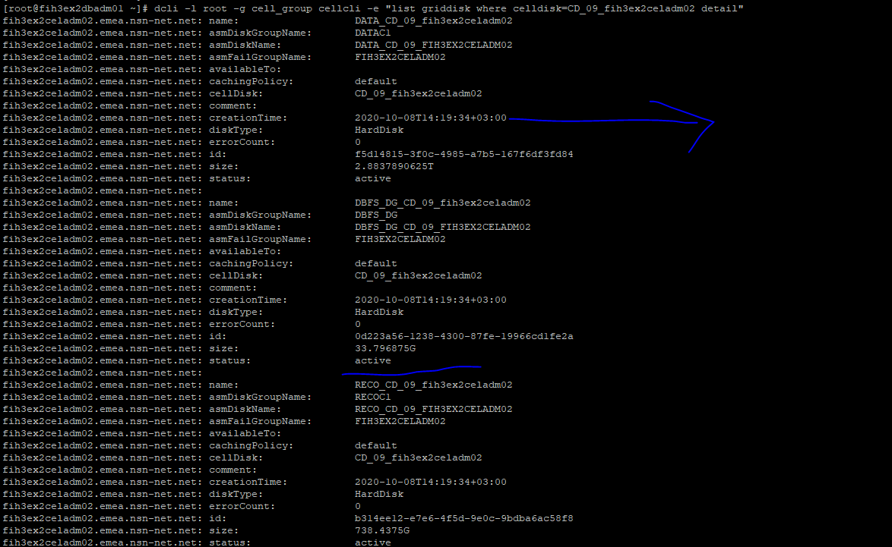

1. Physical Disk Status

Note: fih3ex2celadm02.emea.nsn-net.net: physicalInsertTime: , fih3ex2celadm02.emea.nsn-net.net: status: , fih3ex2celadm02.emea.nsn-net.net: physicalFirmware:

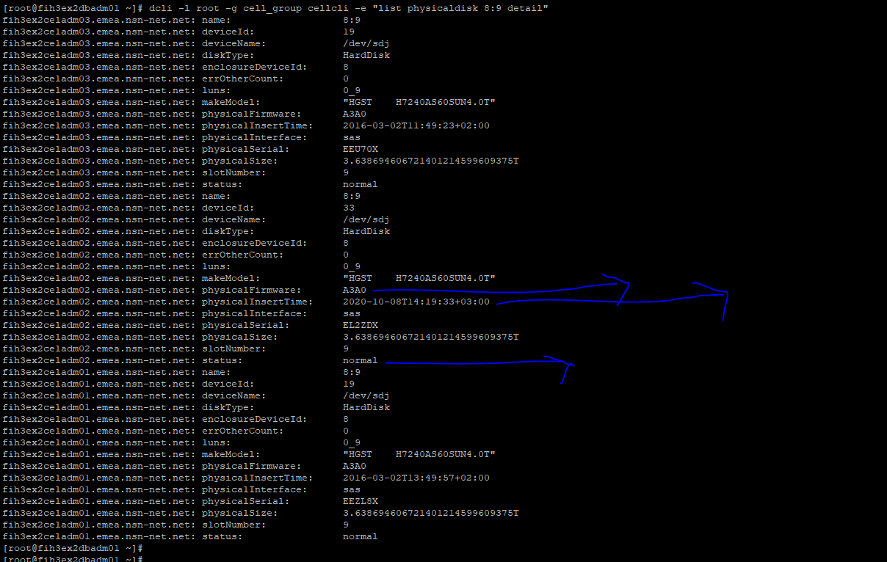

After post checks done do increase the rebalancing power

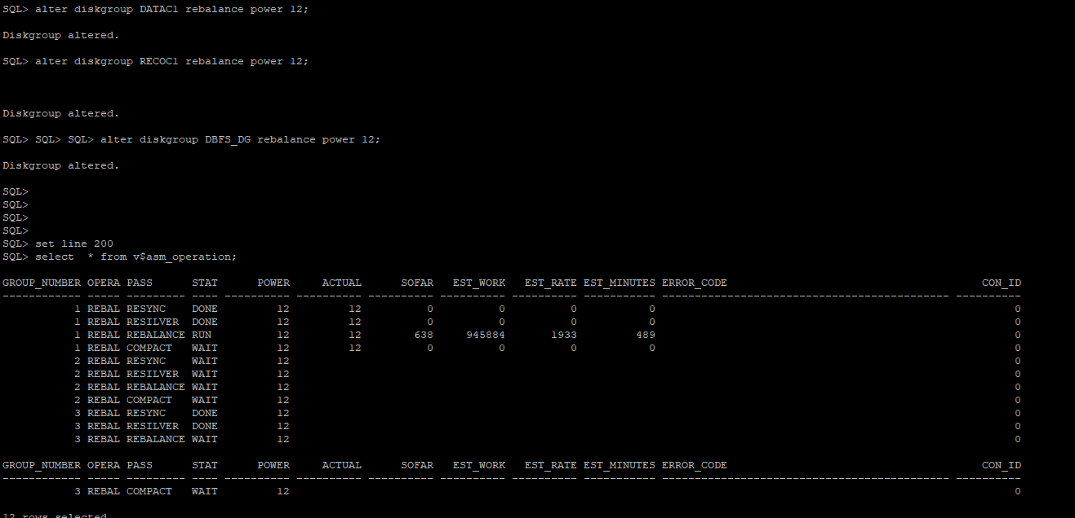

Current Storage status

